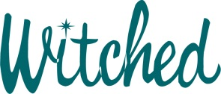- designed by Mischa Hof 2001

This is font was created with the aid of the original

cartoon drawings from the opening sequence of the

TV show **Bewitched**. The animation artists created the original

letters 'Bewitched' only for the show and nothing else.

I have worked hard for over 3 years to re-created

the rest of the letters and more, hand drawn, as authentic as possible to honor

the original logo and its creators. This font contains a full alphabet and numbers.

Font is Free for personal use.

***Commercial use license cost is $45 and can be obtained by contacting me, the author, at***[***mischahof04@gmail.com***](mailto:mischahof04@gmail.com)

Thank you for supporting an artist and his works.

Original Copyright ScreenGems™ 1964.

Re-creation Mischa Hof . 2001

Amendment Mischa Hof 2017